May 22, 2026

NOTICE OF SUBJECT MATTER HEARING

Notice is hereby given that the Chicago City Council
COMMITTEE ON HOUSING AND REAL ESTATE
will host a subject matter hearing on
Wednesday, June 3, 2026, at 10:00 a.m.
Council Chambers, City Hall, 121 N. LaSalle Street, 2nd Floor.

Each person participating in public comment shall have up to three (3) minutes to address all items on the agenda during the public comment period. The Committee will not conduct separate public comments for each agenda item.

Written public comment on any items listed on the agenda will be accepted at committeeonhousingandrealestate@cityofchicago.org until 5:00 p.m. on
Tuesday, June 2, 2026.

Copies of the Agenda of Matters to be considered at this meeting will be made available electronically on the City Clerk’s website.

NO VOTES WILL BE TAKEN AT THIS MEETING.

Sincerely,
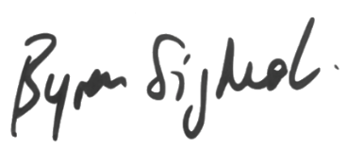

Byron Sigcho-López
Chairman, Committee on Housing & Real Estate

