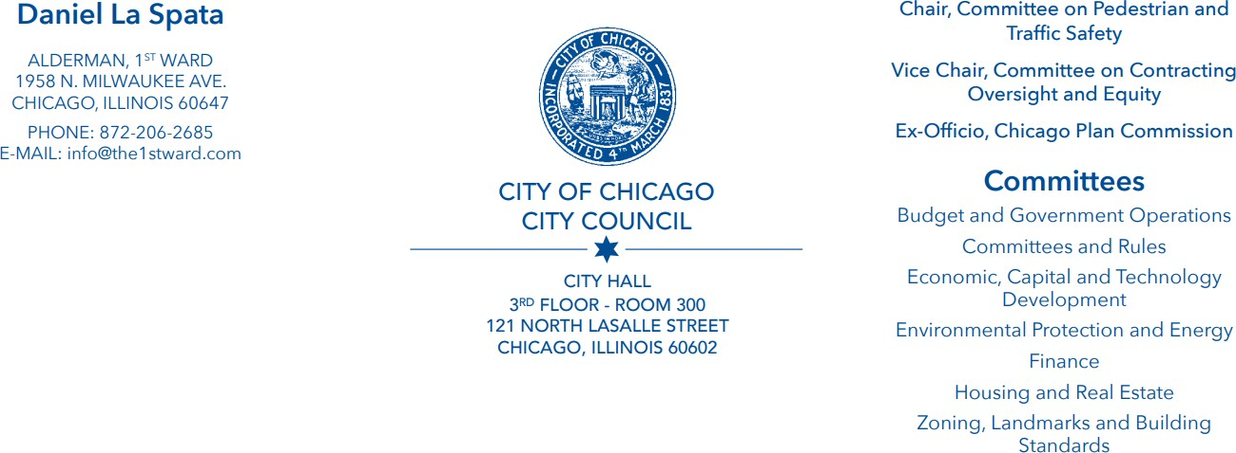

August 03, 2023

NOTICE OF MEETING

Notice is hereby given that the Chicago City Council COMMITTEE ON PEDESTRIAN AND TRAFFIC SAFETY
Will hold a meeting Wednesday, September 6th, 2023 at 2:00pm in City Council Chambers, City Hall, 121 North LaSalle

Written public comment will be accepted at committeeonpedestrianandtrafficsafety@cityofchicago.org until 10:00am Tuesday, September 5, 2023.

The Direct Introduction deadline is 5:00pm on Thursday, August 24th.

Copies of the Agenda of Matters to be considered at this meeting will be made available electronically on the Chicago City Clerk’s website.

Sincerely,
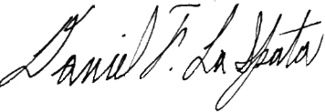
Daniel La Spata, Chairman Committee on Pedestrian and Traffic Safety

